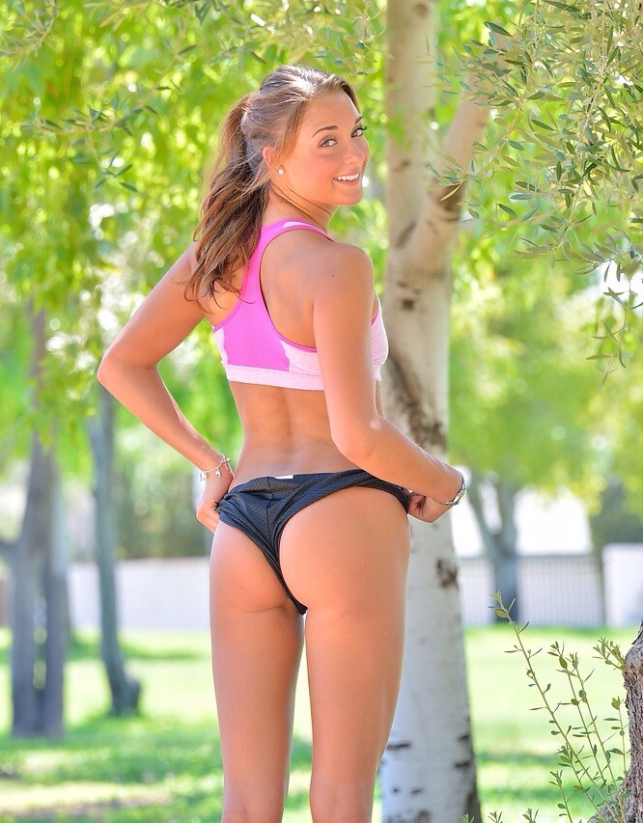

"As if it wasn’t humiliating enough being beaten in a race by my girlfriends sister, but she decides to knowingly play on my PE problem by flashing her perfectly sculpted ass. I hunched forward and released a big load of cum into my shorts. Beaten and defeated as she so confidently smiles back at me"

